TITLE OF PROJECT
(Uppercase, centered, 18 point)

NAME OF STUDENT
(Uppercase, centered, 18 point)

A project report submitted in partial fulfilment
of the requirements for the award of
Bachelor of Information Technology (Hons)
(Centered, 18 point)

Faculty of Engineering, Built Environment, and Information Technology
SEGi University
(Uppercase, centered, 18 point)

(Uppercase, centered, 18 point)
Month year
DECLARATION

I hereby declare that this project report is based on my original work except for citations and quotations which have been duly acknowledge. I also declare that it has not been previously and concurrently submitted for any other degree or award at SEGI UNIVERSITY or other institutions.

Signature: _____________________________
Name: _____________________________
ID No: _____________________________
Date: _____________________________

APPROVAL FOR SUBMISSION

I certify that this project report entitled “TITLE TO BE THE SAME AS FRONT COVER, CAPITAL LETTER BOLD” was prepared by STUDENT’S NAME has met the required standard for submission in partial fulfilment of the requirements for the award of Bachelor of Information Technology (Hons) at SEGi University.

Approved by:
Signature: ______________________
Supervisor: ______________________
Date: ______________________

The copyright of this report belongs to the author under the terms of the copyright Act 1987 as qualified by Intellectual Property Policy of SEGi University. Due acknowledgement shall always be made of the use of any material contained in or derived from this report.
© Year, Name of candidate. All rights reserved.

ACKNOWLEDGEMENT
In preparing this final year project, I was in contact with many people, researchers, academicians, and practitioners. They have contributed towards my understanding and thoughts. In particular, I wish to express my sincere appreciation to my main thesis supervisor, ……
possible to list all of them in this limited space. I am grateful to all my family member.

ABSTRACT
The purpose of this study is to investigate the application of genetic algorithm (GA) in modelling linear and non-linear dynamic systems and develop an alternative model structure selection algorithm based on GA. Orthogonal least square (OLS), a gradient descent method was used as the benchmark for the proposed algorithm. A model structure selection based on modified genetic algorithm (MGA) has been proposed in this study to reduce problems of premature convergence in simple GA (SGA). The effect of different combinations of MGA operators on the performance of the developed model was studied and the effectiveness and shortcomings of MGA were highlighted. Results were compared between SGA, MGA and benchmark OLS method. It was discovered that with similar number of dynamic terms, in most cases, MGA performs better than SGA in terms of exploring potential solution and outperformed the OLS algorithm in terms of selected number of terms and predictive accuracy. In addition, the use of local search with MGA for fine-tuning the algorithm was also proposed and investigated,).

TABLE OF CONTENTS
 | TITLE | PAGE

APPROVAL FOR SUBMISSION iii
ACKNOWLEDGEMENT v
ABSTRACT vi
TABLE OF CONTENTS vii
LIST OF TABLES x
LIST OF FIGURES xi
LIST OF APPENDICES xii
CHAPTER 1 INTRODUCTION 1
1.1 Introduction 1
1.2 Problem Background 1
1.3 Problem Statement 2
1.4 Aims and Objectives 2
1.4.1 Project Aim 2
1.4.2 Project Objectives 2
1.5 Project Scope 3
1.6 Significance of the Project 3
1.7 Organization of the Report 3
CHAPTER 2 LITERATURE REVIEW 5
2.1 Introduction 5
2.2 Your topic/area 5
2.2.1 Further discussion on the topic/area 6
2.3 Similar Existing System 6
2.3.1 Carousell 6
2.3.2 HappyFresh 6
2.4 Comparison between …… 7
2.5 Proposed Solution 7
2.6 Development Platform 8
2.6.1 Web Based 8
2.6.2 Mobile Based 8
2.6.3 Justification for Selection of ……. 8
2.7 Software Development Model 8
2.8 Chapter Summary 8
CHAPTER 3 METHODOLOGY, ANALYSIS AND DESIGN 9
3.1 Introduction 9
3.1.1 Proposed Methodology 9
3.1.1.1 Methodology Activities 9
3.2 System Analysis 10
3.2.1 Functional and Non-Functional Requirements 10
3.2.2 Use Case Diagram 10
3.2.3 Use Case Descriptions 11
3.3 System Design 11
3.3.1 Sequence Diagram 11
3.3.2 Class Diagram 11
3.4 Data Modeling 12
3.4.1 Data Dictionary 12
3.4.2 Entity Relationship Diagram 12
3.5 Proposed Story Board 12
3.5.1 Login/Logout Page (if exist) 12
3.5.2 Home Page 12
3.5.3 XXX Page 12
3.5.4 YYY Page 12
3.6 Test Plan 12
3.7 Chapter Summary 12
CHAPTER 4 IMPLEMENTATION 13
4.1 Introduction 13
4.2 Development Environment 13
4.3 System Development 13
4.3.1 Database Development 13
4.3.2 User Interface Development 13
4.3.3 Programming Code Development 13
4.3.3.1 Application Programming Interface (API) 13
4.3.4 Data implementation 14
4.4 Test Results 14
4.5 Chapter Summary 14
CHAPTER 5 RESULTS AND DISCUSSION 15
5.1 Introduction 15
5.2 Results of the Project 15
5.2.1 Registration Page (example) 15
5.2.2 Order Page (example) 15
5.3 Evaluation of the Product 15
5.4 Evaluation of the Project Process 16
5.5 Chapter Summary 16
CHAPTER 6 CONCLUSION AND RECOMMENDATIONS 17
6.1 Introduction 17
6.2 Project Result and Achievement 17
6.3 Advantages of the Application/Website/System 17
6.4 Recommendation for Future Enhancement 17
6.5 Conclusion 17
REFERENCES 19

LIST OF TABLES
TABLE NO. | TITLE | PAGE
Table 2.1 Example Repeated Header Table Error! Bookmark not defined.
Table 2.2 Example Repeated Header Table 7

LIST OF FIGURES
FIGURE NO. | TITLE | PAGE
Figure 2.1 Trends leading to the problem using MZJ Formatting Method 5
Figure 3.1 Example of Formatting Method 10
Figure 3.2 Example of Formatting Method 11

LIST OF APPENDICES
APPENDIX | TITLE | PAGE
Appendix A Requirement Specification 21
Appendix B Project Proposal Form 22
Appendix C Progress Log Sheets 23

INTRODUCTION

Introduction

Problem Background
Video provides a powerful way to help you prove your point. When you click Online Video, you can paste in the embed code for the video you want to add. You can also type a keyword to search online for the video that best fits your document. To make your document look professionally produced, Word provides header, footer, cover page, and text box designs that complement each other. For example, you can add a matching cover page, header, and sidebar. “For the first paragraph, use ‘Para 2 lines’ style”
Video provides a powerful way to help you prove your point. When you click Online Video, you can paste in the embed code for the video you want to add. You can also type a keyword to search online for the video that best fits your document. To make your document look professionally produced, Word provides header, footer, cover page, and text box designs that complement each other. For example, you can add a matching cover page, header, and sidebar. Click Insert and then choose the elements you want from the different galleries. Themes and styles also help keep your document coordinated. When you click Design and choose a new Theme, the pictures, charts, and SmartArt graphics change to match your new theme. “For the last paragraph/single paragraph in the section, use ‘Para 4 lines’ style”

Problem Statement
Video provides a powerful way to help you prove your point. When you click Online Video, you can paste in the embed code for the video you want to add. You can also type a keyword to search online for the video that best fits your document. To make your document look professionally produced, Word provides header, footer, cover page, and text box designs that complement each other. For example, you can add a matching cover page, header, and sidebar. Click Insert and then choose the elements you want from the different galleries.

Aims and Objectives
Video provides a powerful way to help you prove your point. When you click Online Video, you can paste in the embed code for the video you want to add. You can also type a keyword to search online for the video that best fits your document.

Project Aim
The aim of the project is to…

Project Objectives
The objectives of the project are as follows:

- To study on ….
- To conduct literature review …
- To capture requirements …..
- To design the …..
- To implement

Project Scope

Significance of the Project

Organization of the Report
Chapter 1: Introduction

Chapter 2: Literature Review

Chapter 3: Methodology, Analysis and Design

Chapter 4: Implementation

Chapter 5: Results and Discussion

Chapter 6: Conclusion and Recommendations

LITERATURE REVIEW

Introduction
Video provides a powerful way to help you prove your point. When you click Online Video, you can paste in the embed code for the video you want to add. You can also type a keyword to search online for the video that best fits your document. To make your document look professionally produced, Word provides header, footer, cover page, and text box designs that complement each other. For example, you can add a matching cover page, header, and sidebar.
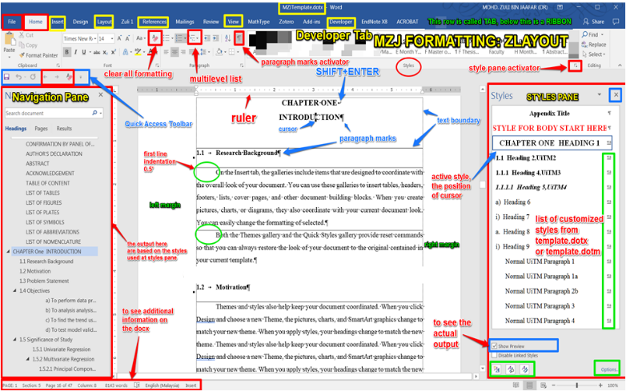
Figure 2.1 Trends leading to the problem using MZJ Formatting Method

Your topic/area
Author1 (2018) indicated that young adults have limited time in their daily life and express the online shopping can give them more valuable time with their family. Author1 (2016) discovered that online shopping is a relatively easy task, which does not require higher education. The online shopping can boost local grocery market (Author3, 2017). Continue research to find out what, why, when, how your project can do to benefit the intended user……..

Further discussion on the topic/area

Similar Existing System
The discussion is carried out with the presentation of similar system identified. The identified application such as Caroussel, Zalora, Smartshopper, HappyFresh and many more. These applications have been in operation for many years and has matured in many ways. ……………………

Carousell

Figure 2.2 Carousell
This application is designed for the users who wants to buy or sell new or used products. The features include a) xxxx b) yyyyy c) zzzzzz. The interface designed with multi colors….. The images were ccccc

HappyFresh
The following is another application used for grocery shopping…..

Figure 2.3 HappyFresh

This application was designed and developed for the users who have no time to go for grocery. What, When, Why, How……….explain further

Comparison between ……
Table 2.1 Example Repeated Header Table
Comparison Item | System 1 | System 2 | System 3

Proposed Solution

Development Platform

Web Based

Mobile Based

Justification for Selection of …….

Software Development Model

Chapter Summary
This chapter is a review conducted on online shopping application, Various shopping applications were discussed in detail. Finally, the survey was conducted and the results help the author to identify…….

METHODOLOGY, ANALYSIS AND DESIGN

Introduction
On the Insert tab, the galleries include items that are designed to coordinate with the overall look of your document. You can use these galleries to insert tables, headers, footers, lists, cover pages, and other document building blocks. When you create pictures, charts, or diagrams, they also coordinate with your current document look. You can easily change the formatting of selected text in the document text by choosing a look for the selected text from the Quick Styles gallery on the Home tab.

Proposed Methodology
On the Insert tab, the galleries include items that are designed to coordinate with the overall look of your document. You can use these galleries to insert tables, headers, footers, lists, cover pages, and other document building blocks. When you create pictures, charts, or diagrams, they also coordinate with your current document look. You can easily change the formatting of selected text in the document text by choosing a look for the selected text from the Quick Styles gallery on the Home tab.

Methodology Activities
On the Insert tab, the galleries include items that are designed to coordinate with the overall look of your document. You can use these galleries to insert tables, headers, footers, lists, cover pages, and other document building blocks. When you create pictures, charts, or diagrams, they also coordinate with your current document look. You can easily change the formatting of selected text in the document text by choosing a look for the selected text from the Quick Styles gallery on the Home tab.

System Analysis
You can easily change the formatting of selected text in the document text by choosing a look for the selected text from the Quick Styles gallery on the Home tab

Functional and Non-Functional Requirements

Use Case Diagram
You can easily change the formatting of selected text in the document text by choosing a look for the selected text from the Quick Styles gallery on the Home tab
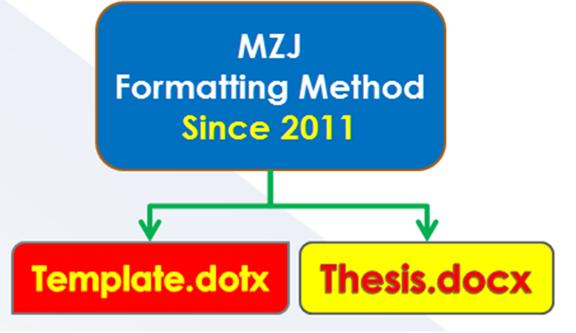
Figure 3.1 Example of Formatting Method

Use Case Descriptions
You can easily change the formatting of selected text in the document text by choosing a look for the selected text from the Quick Styles gallery on the Home tab

System Design
You can easily change the formatting of selected text in the document text by choosing a look for the selected text from the Quick Styles gallery on the Home tab

Sequence Diagram
You can easily change the formatting of selected text in the document text by choosing a look for the selected text from the Quick Styles gallery on the Home tab
Figure 3.2 Example of Formatting Method

Class Diagram
You can easily change the formatting of selected text in the document text by choosing a look for the selected text from the Quick Styles gallery on the Home tab

Data Modeling

Data Dictionary

Entity Relationship Diagram
The following is a description of data modeling for this project.

Proposed Story Board
Proposed interface design (wireframe)

Login/Logout Page (if exist)

Home Page
You can easily change the formatting of selected text in the document text by choosing a look for the selected text from the Quick Styles gallery on the Home tab

XXX Page

YYY Page

Test Plan

Chapter Summary

IMPLEMENTATION

Introduction

Development Environment
Students must describe development environment in implementing the project. Describe development tools required for the implementation such as IDE, Plugins, Database.

System Development

Database Development

User Interface Development

Programming Code Development

Application Programming Interface (API)

Data implementation
The following are the data ……
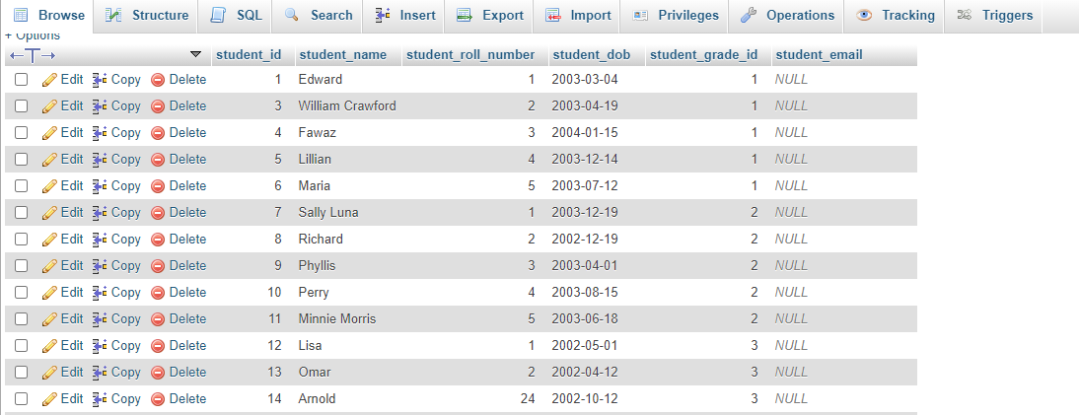
Figure 4.3 Customer Table

Figure 4.3 shows customer table prepared for the system. The tables consists of XX colums which include colmns: name, id, age,……. (This is how you write…)

Test Results

Chapter Summary
Summarise the chapter.

RESULTS AND DISCUSSION

Introduction

Results of the Project
In this section you should describe to what extent you achieved your goals. You should describe how you demonstrated that the system works as intended (or not, as the case may be). Include comprehensible summaries of the results of all critical tests that were carried out. You might not have had the time to carry out any full rigorous tests – you may not even got as far as producing a testable system. However, you should try to indicate how confident you are about whatever you have produced, and also suggest what tests would be required to gain further confidence.

Registration Page (example)
Figure 5.1 show the Registration Page.

Order Page (example)
Figure 5.2 shows the Order Page.

Evaluation of the Product
Identify the strengths and weaknesses of your product in meeting its requirements and review the possible alternative technical approaches to its design and implementation. You can include successes and failures of the development such as unresolved design problems. You should identify which are the important features of the design. You may point out significant design or implementation techniques and a discussion of mistakes made in the design, and the problems that they caused. In case if the objectives of your project have been changed prior to FYP1 submission, you should discuss the reasons for the change.

Evaluation of the Project Process
It should address the way in which you undertook and managed the project (the process); actual progress made. The emphasis should be on the learning process and how well you managed your project work.

Chapter Summary
Summarise the chapter.

CONCLUSION AND RECOMMENDATIONS

Introduction
This chapter is an important since it gives an overall significance of the study. Stresses the findings upon which a conclusion or conclusions are drawn in line with the objectives set, acknowledges the limitations and suggests further research and recommendations which may be usefully carried out on the topic.

Project Result and Achievement

Advantages of the Application/Website/System

Recommendation for Future Enhancement

Conclusion

REFERENCES
Chen, M.-C. and Huang, S.-H. (2003) ‘Credit scoring and rejected instances reassigning through evolutionary computation techniques’, Expert Systems with Applications, 24(4), pp. 433–441.
Clerc, M. and Kennedy, J. (2002) ‘The particle swarm - explosion, stability, and convergence in a multidimensional complex space’, IEEE Transactions on Evolutionary Computation, 6(1), pp. 58–73.
Gosnell, M., Woodley, R., Hicks, J. and Cudney, E. (2014) ‘Exploring the Mahalanobis-Taguchi Approach to Extract Vehicle Prognostics and Diagnostics’, in Computational Intelligence in Vehicles and Transportation Systems (CIVTS), 2014 IEEE Symposium on, pp. 84–91.
Gupta, A. (2015) ‘Classification of Complex UCI Datasets Using Machine Learning Algorithms Using Hadoop’, International Journal of Scetific & Techology Research, 4(5), pp. 85–94.
Hu, J., Zhang, L., Liang, W. and Wang, Z. (2009) ‘Incipient mechanical fault detection based on multifractal and MTS methods’, Petroleum Science, 6(2), pp. 208–216.
Huang, C.-L., Chen, Y. H. and Wan, T.-L. J. (2012) ‘The mahalanobis taguchi system—adaptive resonance theory neural network algorithm for dynamic product designs’, Journal of Information and Optimization Sciences, 33(6), pp. 623–635.
Jain, A. K. A. K., Duin, R. P. W. and Mao, J. (2000) ‘Statistical pattern recognition: a review’, IEEE Transactions on Pattern Analysis and Machine Intelligence, 22(1), pp. 4–37.
Khalid, S., Khalil, T. and Nasreen, S. (2014) ‘A survey of feature selection and feature extraction techniques in machine learning’, 2014 Science and Information Conference, pp. 372–378.
Li, C., Yuan, J. and Qi, Z. (2015) ‘Risky group decision-making method for distribution grid planning’, International Journal of Emerging Electric Power Systems, 16(6), pp. 591–602.

Appendix A

Appendix B

Appendix C

Appendix D

